**LAB PROGRAM 5 (FLIGHT DATABASE) Name: Tarun Sriram D**

**USN: 1BM19CS171**

**Queries:**

|  |
| --- |
|  |
| create database flightdb; |
|  | use flightdb; |
|  |  |
|  | create table flights( |
|  | flno int, |
|  | fromplace varchar(15), |
|  | toplace varchar(15), |
|  | distance int, |
|  | departs datetime, |
|  | arrives datetime, |
|  | price int, |
|  | primary key (flno) |
|  | ); |
|  | desc flights; |
|  | create table aircraft( |
|  | aid int, |
|  | aname varchar(15), |
|  | cruisingrange int, |
|  | primary key (aid) |
|  | ); |
|  | desc aircraft; |
|  | create table employees ( |
|  | eid int, |
|  | ename varchar(15), |
|  | salary int, |
|  | primary key (eid) |
|  | ); |
|  | desc employees; |
|  | create table certified ( |
|  | eid int, |
|  | aid int, |
|  | foreign key (eid) references employees(eid), |
|  | foreign key (aid) references aircraft(aid) |
|  | ); |
|  | desc certified; |
|  | insert into flights values(101, 'Bangalore', 'Delhi', 2500, '2005-05-13 07:15:31', '2005-05-13 18:15:31', 5000); |
|  | insert into flights values(102, 'Bangalore', 'Lucknow', 3000, '2013-05-05 07:15:31', '2013-05-05 11:15:31', 6000); |
|  | insert into flights values(103, 'Lucknow', 'Delhi', 500, '2013-05-05 12:15:31', '2013-05-05 17:15:31', 3000); |
|  | insert into flights values(107, 'Bangalore', 'Frankfurt', 8000, '2013-05-05 07:15:31', '2013-05-05 22:15:31', 60000); |
|  | insert into flights values(104, 'Bangalore', 'Frankfurt', 8500, '2013-05-05 07:15:31', '2013-05-05 23:15:31', 75000); |
|  | insert into flights values(105, 'Kolkata', 'Delhi', 3400, '2013-05-05 07:15:31', '2013-05-05 09:15:31', 7000); |
|  | insert into flights values(106, 'Bangalore', 'Kolkata', 1000, '2013-05-05 01:15:30', '2013-05-05 09:20:30', 10000); |
|  | insert into flights values(108, 'Lucknow', 'Kolkata', 1000, '2013-05-05 11:30:30', '2013-05-05 15:20:30', 10000); |
|  |  |
|  | commit; |
|  |  |
|  | select * from flights; |
|  |  |
|  | insert into aircraft values(101, '747', 3000); |
|  | insert into aircraft values(102, 'Boeing', 900); |
|  | insert into aircraft values(103, '647', 800); |
|  | insert into aircraft values(104, 'Dreamliner', 10000); |
|  | insert into aircraft values(105, 'Boeing', 3500); |
|  | insert into aircraft values(106, '707', 1500); |
|  | insert into aircraft values(107, 'Dream', 120000); |
|  | insert into aircraft values(108, '707', 760); |
|  | insert into aircraft values(109, '747', 1000); |
|  | commit; |
|  |  |
|  | select * from aircraft; |
|  |  |
|  | insert into employees values(701, 'A', 50000); |
|  | insert into employees values(702, 'B', 100000); |
|  | insert into employees values(703, 'C', 150000); |
|  | insert into employees values(704, 'D', 90000); |
|  | insert into employees values(705, 'E', 40000); |
|  | insert into employees values(706, 'F', 60000); |
|  | insert into employees values(707, 'G', 90000); |
|  | commit; |
|  |  |
|  | select * from employees; |
|  |  |
|  | insert into certified values(701, 101); |
|  | insert into certified values(701, 102); |
|  | insert into certified values(701, 106); |
|  | insert into certified values(701, 105); |
|  |  |
|  | insert into certified values(702, 104); |
|  | insert into certified values(703, 104); |
|  | insert into certified values(704, 104); |
|  |  |
|  | insert into certified values(702, 107); |
|  | insert into certified values(703, 107); |
|  | insert into certified values(704, 107); |
|  |  |
|  | insert into certified values(702, 101); |
|  | insert into certified values(702, 108); |
|  | insert into certified values(701, 109); |
|  | commit; |
|  | select * from certified; |
|  |  |

**Aircraft Table :**

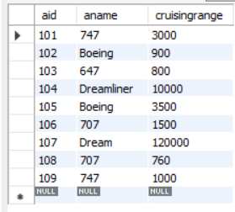

**Employees Table:**

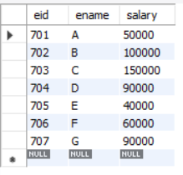

**Certified Table :**

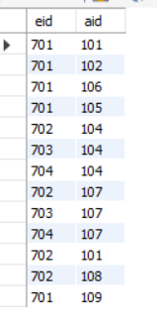

**Flights Table:**

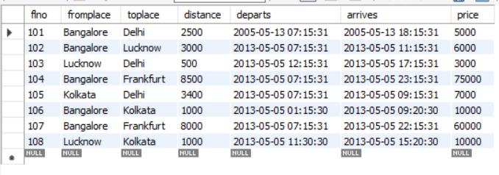

**ADDITIONAL QUERIES**

**Query 1:**

select distinct a.aname from aircraft a where a.aid in (

select c.aid from certified c, employees e where

c.eid = e.eid and not exists(

select * from employees e1 where e1.eid=e.eid and e1.salary<80000

)

);

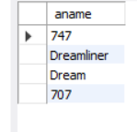**Result:**

**Query 2:**

select max(a.cruisingrange), c.eid from certified c, aircraft a where c.aid = a.aid group by c.eid having count(c.eid)>3;

**Result:**

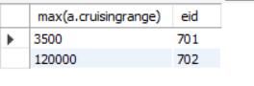

**Query 3:**

select ename from employees where salary <(

select min(price) from flights where fromplace='Bangalore' and toplace='Frankfurt');

**Result:**

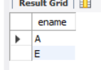

**Query 4:**

select avg(e.salary), c.aid from certified c, employees e where c.aid in(

select aid from aircraft where cruisingrange>1000) and e.eid = c.eid group by c.aid;

**Result:**

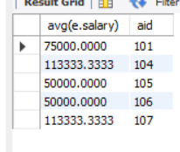

**Query 5:**

select ename from employees where eid in(

select eid from certified where aid in(

select aid from aircraft where aname = 'Boeing'));

**Result:**

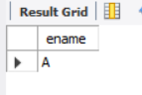

**Query 6:**

select aname from aircraft where cruisingrange > any (select distance from flights where fromplace='Bangalore' and toplace='Delhi');

**Result:**

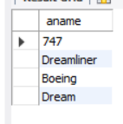

**Query 7:**

SELECT F.flno, F.departs

FROM flights F

WHERE F.flno IN ( ( SELECT F0.flno

FROM flights F0

WHERE F0.fromplace = 'Bangalore' AND F0.toplace = 'Kolkata'

AND extract(hour from F0.arrives) < 18 )

UNION

( SELECT F0.flno

FROM flights F0, flights F1

WHERE F0.fromplace = 'Bangalore' AND F0.toplace <> 'Kolkata'

AND F0.toplace = F1.fromplace AND F1.toplace = 'Kolkata'

AND F1.departs > F0.arrives

AND extract(hour from F1.arrives) < 18)

UNION

( SELECT F0.flno

FROM flights F0, flights F1, flights F2

WHERE F0.fromplace = 'Bangalore'

AND F0.toplace = F1.fromplace

AND F1.toplace = F2.fromplace

AND F2.toplace = 'Kolkata'

AND F0.toplace <> 'Kolkata'

AND F1.toplace <> 'Kolkata'

AND F1.departs > F0.arrives

AND F2.departs > F1.arrives

AND extract(hour from F2.arrives) < 18));

**Result:**

